Visual Representation of Elements in ‘The Bean Trees’
Name
Institution
Date

Visual Representation of Elements in ‘The Bean Trees’
Setting
‘The Bean Trees’ was developed in the early 1980s. The novel opens in rural Kentucky (Kingsolver & Wragge, 2009). The book shows how Taylor Greer (the novel protagonist) travels across the country to Tucson, Arizona, where she settles. Taylor shares a brief story of Newt Hardline, who died while she was in high school (Alazzawi, 2019). Taylor had escaped form a small-town life, and she did so to avoid pregnancy and to get jobs. Five years after graduating from high school, Taylor leaves to Pittman County, Kentucky (Alazzawi, 2019). At the end of the novel, Taylor takes a fascinating trip to Oklahoma prior to returning to Tucson.
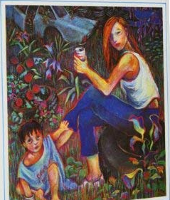
Fig 1.1
The major conflict in ‘The Bean Trees’ emerges when Taylor agreed to take the responsibility to take care of Turtle in addition to understanding the predicament of political refugees. In the rising action, Kingsolver and Wragge presents how Taylor received Turtle, grew close to friends and learned the story of Estevan and Esperanza. The conflict becomes quite evident when Taylor made choice to raise/nurture Turtle (Kingsolver & Wragge, 2009), while putting her safety into risks for the affiliated accusations.
Theme: The Shared Burden of Womanhood
Themes are basic and quite essential ideas explored and presented in literacy work. The theme of ‘The Shared Burden of Womanhood’ is quite outspoken in the novel. The author explored the topic of gender in two broader ways. At first, the novel presents an image of the success of a nearly exclusively female world (Alazzawi, 2019). For instance, Taylor lives in a small community of women who, in most part, live their lives independently of men (Alazzawi, 2019). It is observable the women in this community are united, and they strengthen each other, as evident with Taylor and Lou Ann. The novel also extends a hand of concern to the aspect of gender inequality as a societal aspect other than a series of individual grievances (Alazzawi, 2019).

Fig 2.0

Character: Turtle
The novel presents Turtle as the little girl Taylor finds at a bar in Oklahoma. She was nicknamed from a type of mid Turtle that clings to rocks. A history of abuse makes Turtle very silent for much of the novel. Turtle appears to be withdrawn, with anxiety remaining unnoticed (Kingsolver & Wragge, 2009). As the novel unfolds, Turtle begins to gain much trust in Taylor, believing that she will manage to take good care of her together with her siblings, a situation which made her increasingly talkative and charming. As the novel progresses, Turtle demonstrates a connection with the earth, taking great pleasure in naming vegetables, in addition to playing with seeds and dirt (Kingsolver & Wragge, 2009). The catalog presents her made-up songs concerning vegetables and her most preferred bedtime. As evident, the love for land connects her to her Native American heritage.
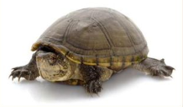
Fig 3.0

References
Alazzawi, A. J. M. (2019). Cultural Eco-Feminism in Barbara Kingsolver’s novel The Bean Trees. Journal of Surra Man Raa, 15(61), 875-894.
Kingsolver, B., & Wragge, E. (2009). The bean trees. Harper Collins Publishers.

